***HomeCooked Post / Recipe Image Verification***

Step 1: Login to an account / Create an account

Creating an account:

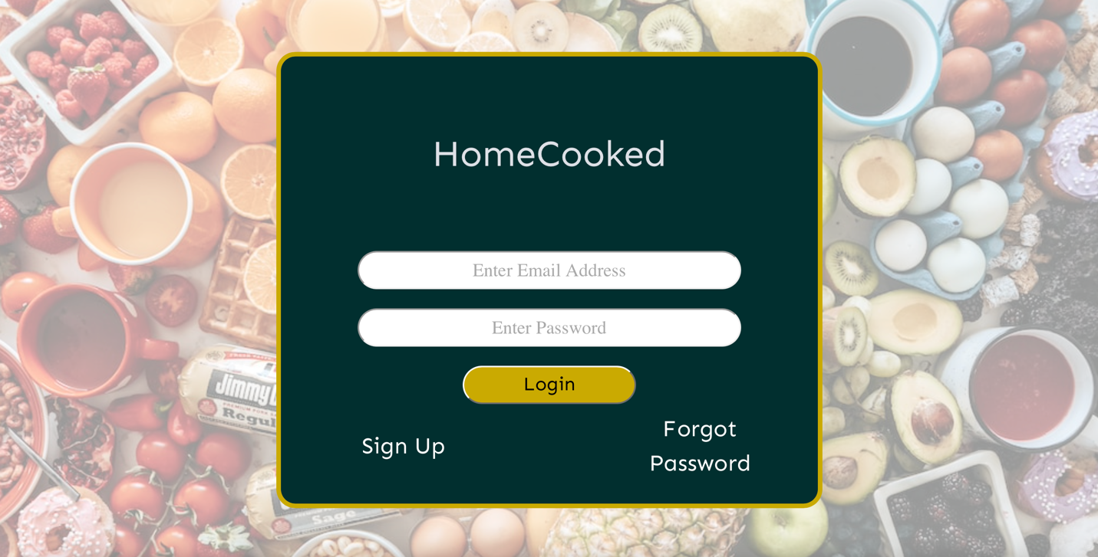

Fill in your information and click sign up:

Logging into an account:

You should now be on your dashboard; this may be populated with current posts.

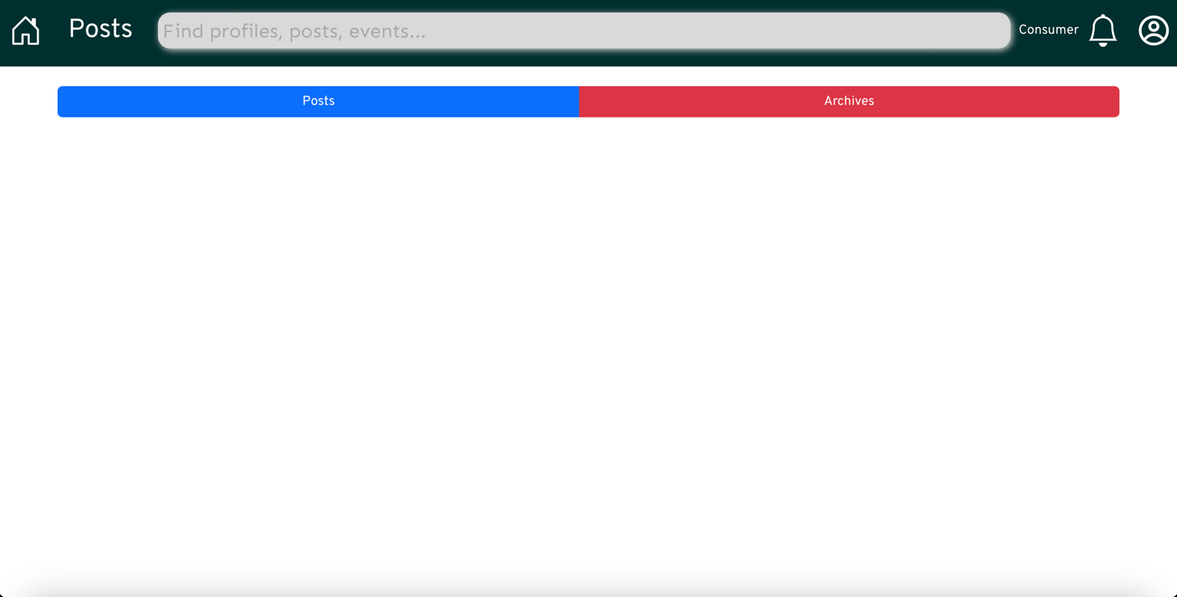

Step 2: Create a post

Switch to Producer mode

Create a new recipe

Fill in the information for the recipe to be included in the post and add recipe

